3/18/2017
Munirah M. Alrushud
Saudi e-university
Around The world
For Travel and Tourism Services
Contents:

- Electronic commerce
- Introduction to E-commerce Page 2
- Types of E-commerce Page 3
- About Around the World
- Introduction to Around the world Page 5
- About the service Page 5
- Business statement Page 5
- Business vision Page 6
- Business objectives Page 6
- E-commerce in our service Page 7
- SWOT analysis Page 8
- E-commerce website (draft) Page 9
- E-commerce system functionality Page 10
- Around the world website design Page 11
- Social media links Page 11
- Functionality needed Page 12
- Hardware and Software needed Page 13
- Type of security needed Page 14
- Potential threats Page 17
- Recommendations Page 18
- Marketing and advertising strategies Page 19
- Demographic Page 19
- Marketing methods Page 20
- Social media Page 21
- Local marketing Page 21
- Multichannel marketing Page 22
- Ethics and laws Page 22
- Conclusion Page 23
Electronic Commerce:

Electronic Commerce (e-commerce) is a type of business that transfer information and processes through the Internet. It digitally enabled commercial transactions between among organizations and individuals. E-commerce covers different types of businesses and allows the consumers to exchange products and services with no barriers of time or distance.

E-commerce has expanded and become even different from the past five years and it may continue at this rate, or even more. Nowadays we have cell phones, tablets, and even laptops so accessing to the internet will be much easier for social medias, education, communicating, entertainment, and even for booking and traveling, all of these and more can be done through the internet.

The e-commerce has improved the business through the internet and expanded the business range. Also, it has simplified the commerce and businesses for the customer and made it easy for them by providing them services in comfortable way.

Some Types of E-Commerce:

There are different types of e-commerce and many ways to describe them. We can identify the different types of e-commerce by the market relationship

- Business-to-Consumer e-commerce:
Is The most commonly type of e-commerce. B2C Commerce is an online business selling to individual consumers. Like purchasing of travel services, goods, and online content. For example: Amazon, and Around the World for travel and services.

- Business-to-Business e-commerce:
Is the largest type of e-commerce. B2B Commerce is an online business selling for other businesses. The ultimate size of B2B e-commerce is potentially huge.

- Consumer-to-Consumer e-commerce:
C2C commerce is and online consumers selling to other consumers. So, it provides a way for consumers to sell to each other. such as eBay or Etsy.

- Social e-commerce:
Is an e-commerce that enabled by social networks and online social relationships. It is sometimes referred to as Facebook commerce, but it is a much larger phenomenon that extends beyond just Facebook. Like signing onto Web sites using your Facebook or other social network ID

- Mobile e-commerce:
Is an e-commerce that used by mobile devices to enable online transactions. M-commerce involves the use of cellular and wireless networks to connect laptops, smartphones such as the iPhone and tablet computers such as the iPad to the Internet.

- Local e-commerce:
is a form of e-commerce that is focused on engaging the consumer based on his or her current geographic location. Local e-commerce is the third prong of the social, mobile, local e-commerce wave. For example: Groupon.

Introduction to Around the World and Its Services:

Around the world is Saudi online company specialize in travel and tourism planning that meet the needs for every traveler, without sacrificing the other sides of destination and companies or community. It provides online services which make it easier for the customers to book and reserve hotels and trips easily.

This company organizes many trips and services inside Saudi Arabia and even all over the world. It characterized by providing an integrated offers of tourist services to satisfy customers.

Business Statement:

Improve the services and products, and creating the best technical solutions that meet the expectations of the customers. And seek to provide integrated packages of travel and tourism products in one site through contract agreements, and global or local partnerships

Business Vision:

Providing the best and comfortable services and trips for customer and gain their trust.

Business Vision:

- Economic objectives:
Profit for the company and contribute to an increase of services.
- Social objectives:
Providing services to many different communities.
- Technical objectives:
Provide all services and integrated packages to fit with all customers.

E-Commerce in our services:

E-commerce brings new business opportunities to the global travel and tourism industry. Around the world company provides a wide range of products and services, that helps the consumer to take advantage of all of these services and products. The customer can easily enter the website and reserve the place he wants at the time he wants as well without any hardship.

E-commerce helps in facilitating the operations of the Buyer and the consumers; By dealing with many organizations and companies to provide the best services and the best products for consumers.

Customers can simply enter the website and search for the place for the tourism, with specifying the date and the travel time and every detail about their trip. Here comes our turn to provide the hotels and the best airlines for our customers. Our team and the customer will communicate in case the customers need some advices or facing some issues.
We most provide convenience trip and services for our customers, and strengthen their confidence on us.

SWOT Analysis:

Strengths | Weaknesses
Reputation.  Easy to access.  Value added.  Maintenance.  Good culture relationship. | Safety and security for the tourist.  Many languages and dialects.  Lake of infrastructure.
Opportunities | Threats
Development of new tourism and products.  Development of market.  New technology.  Growth rates. | New competitors.  Economy threats.  Seasonal demand.  Exchange rates.

Around the world website (draft):

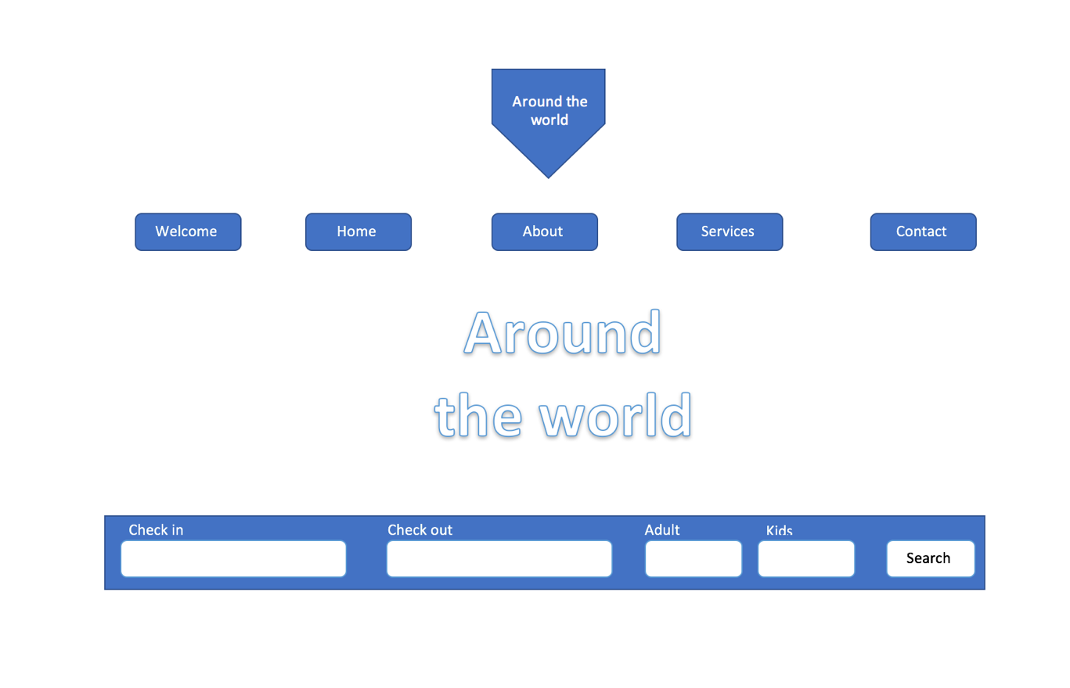

Around the world service’s functionality:

Provides choices for customers in many different cities:
This function can provide helpful way that helps the customer by showing them many perfect choices, and cities with the highest rate.
Provides the best deals and prices all over the world:
We always care for hotels’ deals and many different places to provide the best services and the best deals for customers, they’ll get a comfortable service with simple way.
Focus on high-demand destinations:
We give a special care for the high and most used places, hotels, and other services in the main page, so the customer can reach it easily, and to show the customers the reviews from other customers.
Offers the easiest way to book and deal with hotels:
Around the world services care in dealing with large dimension and places that customers are interested on. Deal with big range in different countries to provide the best and wide service to satisfy the needs of all kind of customers.
Around the world website design:
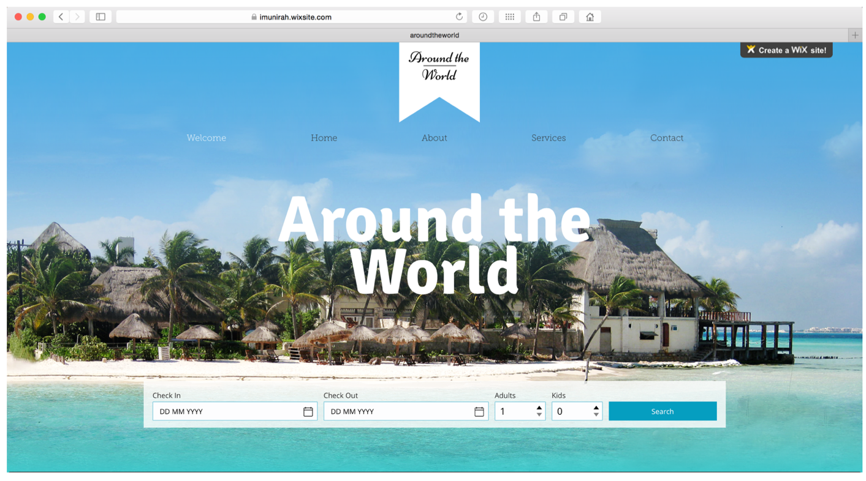

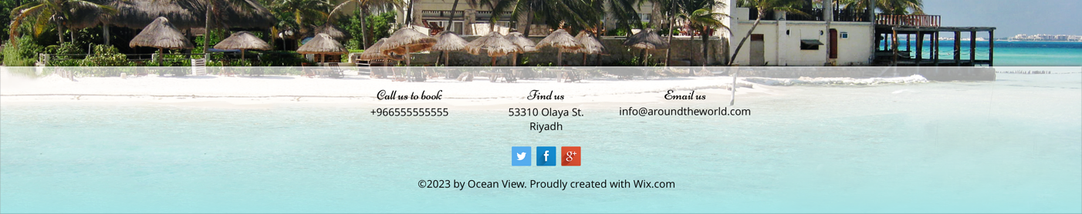
Social media links:

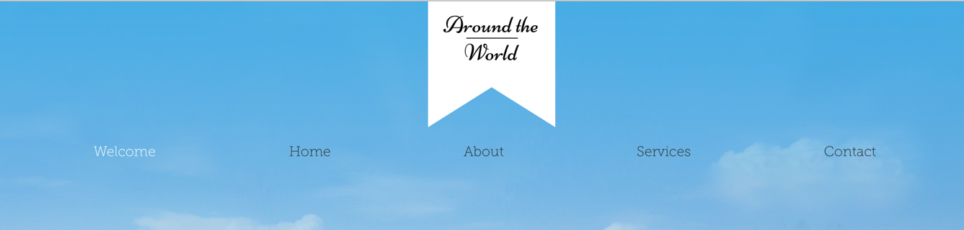
Menu selection:
Functionality Needed:
Clear user interface:
The website should be clear and simple to deal with. Because there are many different types of customers most enter the site and deal with it. It should satisfy the need of all users and customers.

Contact Information:
The most important business detail is contact information, it should be visible and accessible. Customers need to be able to contact and to get in touch with a business or service’ needed.

Clear navigation:
Clear navigation is one of the most important part in the website. The navigation most be easy-to-understand or logical names for all the pages of your site.

Security:
When selling anything online, you need to put some interest into securing your site. we need to encrypt communications between the seller and customers (the credit card number, Social Security number, and so on).

Social media integration:
Twitter, Facebook, Google Plus, LinkedIn, Instagram, and more platform are important. Adding all these platforms into your website will help to improve your business.

The Hardware and Software Needed:
As it known, our services are provided online so there’s not much hardware needed in this business.
We must provide several computers or PCs for all employees and team members.

Web servers:
can be a hardware or software (computer or computer application) helps to transfer content through the internet.

Browsers:
Helps to display the web page in the internet. Like Safari, Google chrome, windows explorer, and more.

Database:
Database system will store the users’ information such as password, name, address, email, and other information to the database.

Types of Security Needed:
Security is determined as the most important part in online store or services. It should be because the website most be entered by any person in anywhere. There are many factors that cause a threat to the website, and other threats such as viruses, hacking, and many of the unlimited threats can face the website and the online companies. Also, we must consider the Authorization and the integrations:

All These Parts Must Be Considered in Developing The Website:

Integrity:
To make sure that the information is displayed in the website and transmitted over the internet and not altered by unauthorized person.

Authorization:
Identify the users or customer identity and their limitation of access, to protect the information so the users not able to access to the personal information of other customers.

Privacy:
Control the use of the customers’ information and allow the customers to schedule themselves. And to express themselves selectively

Availability:
Make sure that the e-commerce website continues to function as what intended or planned to.
Confidents:
Allow the authorized customers to view the message and data that is available for them only not others.

Payment:
The electronic payment should be secure, and we must ensure that we commit the payment for the services over the internet with high security and protection.

“CAPTCHA”:
Considering the CAPTCHA (Completely Automated Public Turing test to tell Computers and Humans Apart) is a type of challenge-response test used in computing to determine whether the user is human or not by using “I’m not robot” in the registration.

The Potential Threats:
Potential threats include

There are many threats are threatening the website such as viruses, worms, Trojan horses, and more. With the unwanted programs such as adware, spyware, and so on. These programs are a security threat that appears when programs are installed on your computer without any acceptance from the users.

Lose of marketing and deals in some places, these losses may alienate customers to other companies or cut off the dealings with our company.

In addition, there’s also a common security threats such as: Cypervandalism, data breach, credit card fraud, spams, etc. The competitors and the Seasonal demand are some threats might face the company, with the economic issues as well.

Recommendations:

Hire an outsourcing or a perfect security team to lead the security and to handle the threats. Dealing with a large number of hotels and tourist places. Offering attractive prices to customers and adding them to the VIP list. Provide many offers and discounts to avoid the Seasonal demands and competitors.

Payment security issues and threat. Is one of the most important threats need to be consider. The customers will add their visa or their credit cards into the website and we most protect their information and their money as well by securing the information.
Make sure to add recommendation space to allow the customers to add their recommendations, to improve our services.

Marketing and advertising strategies:

Demographic:
The structure of societies is continuously changing:
The world population is forecast to grow to 8.3 billion in 2030, life expectancy is projected to increase in most of the world, households and families are becoming more diverse, and migration is changing the face of societies.

All these changes will impact upon the types of tourists and travelers, where they originate from, where they travel to, the types of accommodation they require and the activities they engage in while travelling. The UNWTO/ETC Report on Demographic Change and Tourism aims to be a reference for destinations and the industry to achieve a better understanding of current and future changes and to anticipate and react upon them in the most competitive way.

It includes a comprehensive analysis of major demographic trends and how these will impact on tourism in specific generating markets focusing on three major trends:
• Population growth and ageing
• Household composition and travel parties
• Migration

Marketing methods:
There are many types and marketing methods: Social media marketing (twitter, Facebook, Instagram, snapchat) all are often used and the perfect in marketing. Offline marketing (traditional marketing) there are many different new ways help in the traditional marketing trying to use technology to involve customers in the marketing. Seasonal marketing or seasonal events offers a great way to meet new consumers. Sometimes these events can be actual changes of weather or national holidays which is one of the best ways in marketing.
Social media:

As I’ve mentioned above, social media is one of the most important means of marketing. In social media, we will meet the large community, different personality, age, genders, and more people. We will absolutely find our customer, or some people are interested in our businesses. There are several trends in the marketing of the E-Commerce (mobile marketing, electronic mail marketing, and social media for sure).

Local marketing:

This trend extends to travelers whom looking for local tourism experiences. Local can also translate to authentic.
Travelers are looking for authentic local experiences. Locally-produced goods offer travelers a sense of authenticity, community and connection to place.

Multichannel marketing:

We can interact with our customers in a direct and indirect multichannel (websites, email, ...etc.) Customers can have many options for getting offers ant for communication with the company as well through the social media, our channel in YouTube, Twitter, Facebook, Instagram, and so on) all just provided to achieve customer satisfaction.

Ethics and lows:

Privacy and rights:
- Honesty and Integrity: we should make a honest decisions and maintaining a high level of personal integrity.
- Treating with respect.
- Encrypts all the personal information and protected it from any attackers.

Conclusion:

The online services four travel and tourism has a perfect experience. people can share their experience that can also help other to achieve their needs. It is expected to grow constantly in years to come with advancements in technology. Online services have provided more effective and efficient which mad many companies to be competing for the name in the online services. So, to be in the top we need to maintain and improve our services more forward. Also, the customers and their satisfactions need to be considered; because they are the important part in the growth of the company. No need to mention the deals and offers that provided for the customer to make our company to be number one in this area of trade.

